Scenario: check windowhandles
Step: Launch "WindowHandlePage" WebPage - PASS
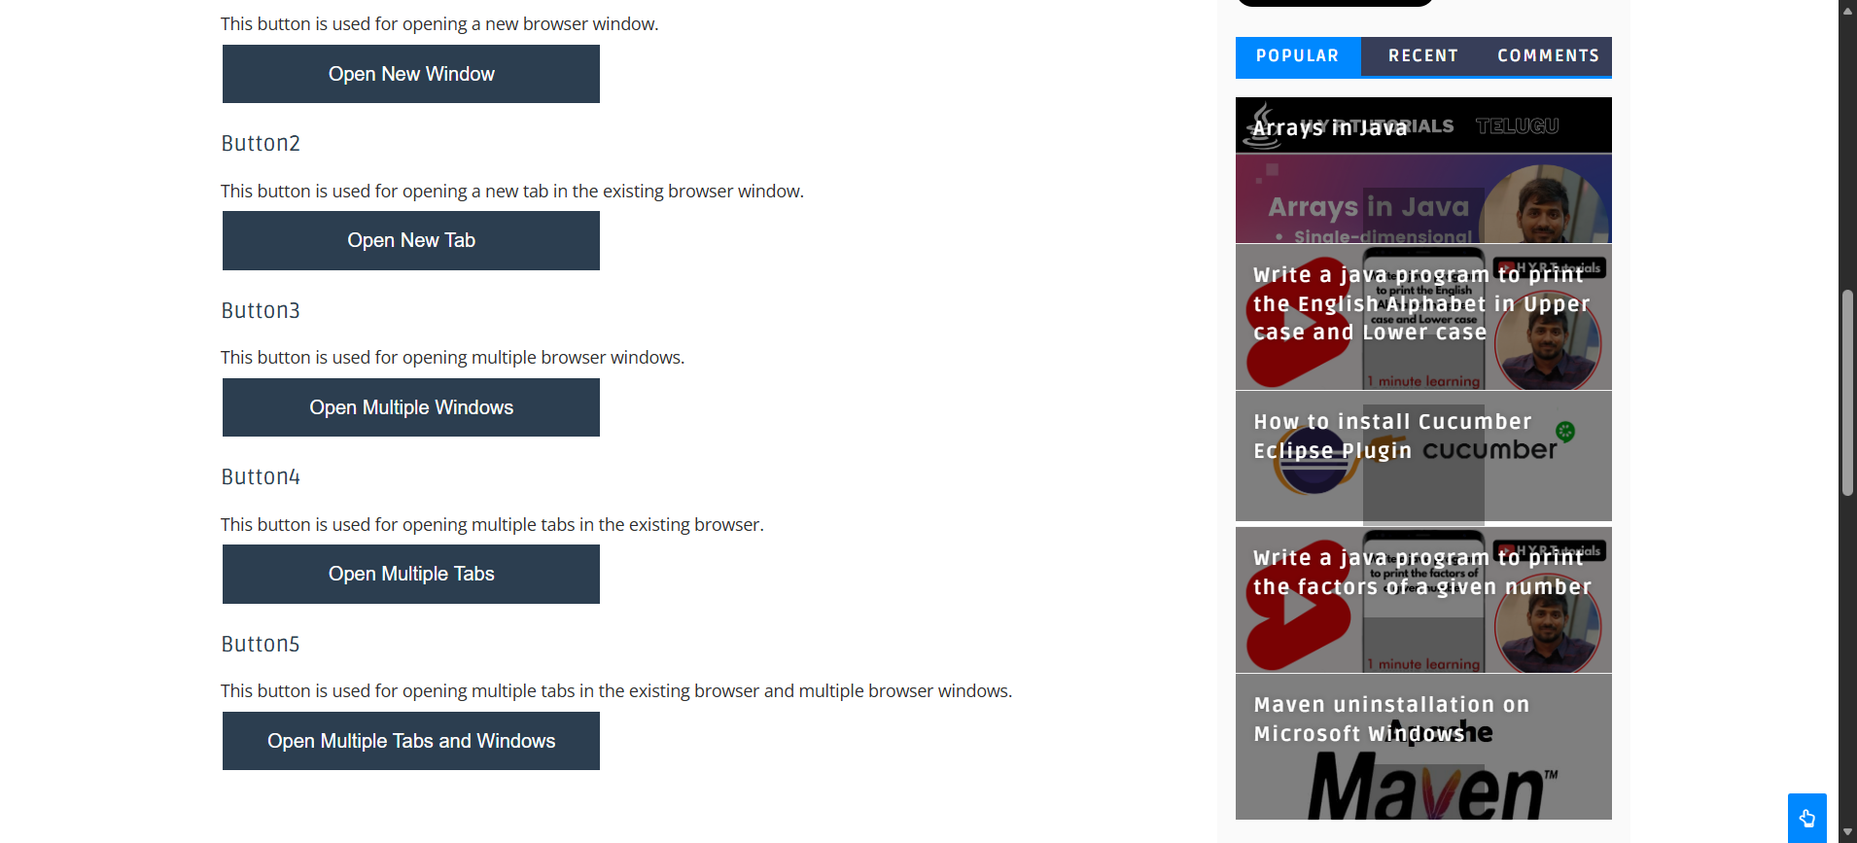
Execution Summary:
Total Steps: 1
Passed: 1
Failed: 0

